1. Create an If function to calculate a total order value based on the following criteria:
   1. If less than 1000 units are ordered each unit costs the normal price

**Answer:**



* 1. Copy the formula down and check that it works.

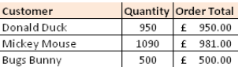

**Answer:**

**=IF(D4<1000,D4*Normal,D4*Discount)**